**DAILY ONLINE ACTIVITIES SUMMARY**

|  |  |  |  |  |  |  |  |  |
| --- | --- | --- | --- | --- | --- | --- | --- | --- |
| **Date:** | **02-07-2020** | | | | | **Name:** | **Anix Jugal D’Cunha** | |
| **Sem & Sec** | **8 sem , A sec** | | | | | **USN:** | **4AL16CS013** | |
| **Online Test Summary** | | | | | | | | |
| **Subject** | | **SMS** | | | | | | |
| **Max. Marks** | | **60** | | **Score** | | | *Marks was not provided through an Email* | |
| **Certification Course Summary** | | | | | | | | |
| **Course** | **Easy learning C++ for beginners** | | | | | | | |
| **Certificate Provider** | | | **Udemy** | | **Duration** | | | 5 hours |
| **Coding Challenges** | | | | | | | | |
| **Problem Statement:** Java Program to find Largest Number in an Array | | | | | | | | |
| **Status: Competed** | | | | | | | | |
| **Uploaded the report in Github** | | | | | **yes** | | | |
| **If yes Repository name** | | | | | **alvas-education-foundation/dcunhaanixjugal** | | | |
| **Uploaded the report in slack** | | | | | **yes** | | | |

Online Test Details: (Attach the snapshot and briefly write the report for the same)

**Marks was not provided through an Email**

Certification Course Details: (Attach the snapshot and briefly write the report for the same)

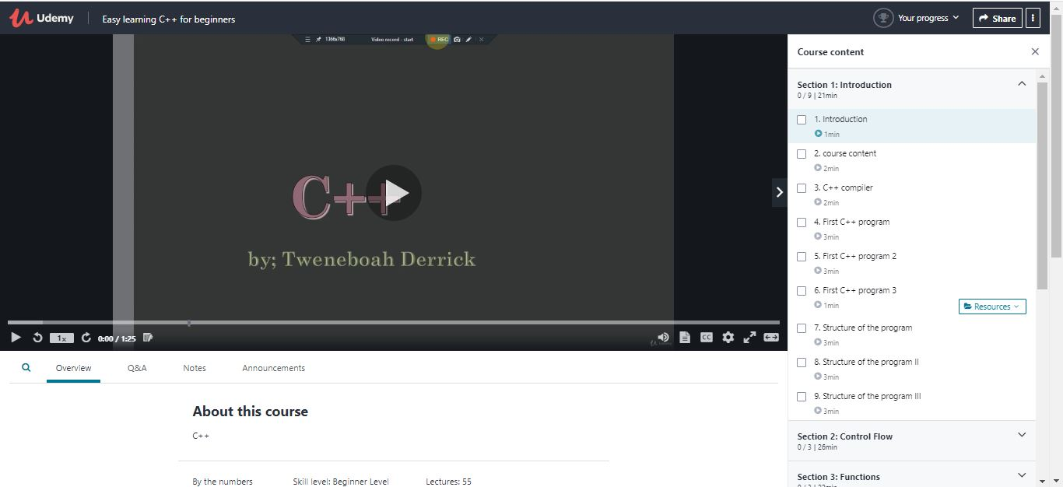

Coding Challenges Details: (Attach the snapshot and briefly write the report for the same)

## Program-> Java Program to find Largest Number in an Array.

|  |  |
| --- | --- |
|  | |
| public class LargestInArrayExample{ |
|  | public static int getLargest(int[] a, int total){ |
|  | int temp; |
|  | for (int i = 0; i < total; i++) |
|  | { |
|  | for (int j = i + 1; j < total; j++) |
|  | { |
|  | if (a[i] > a[j]) |
|  | { |
|  | temp = a[i]; |
|  | a[i] = a[j]; |
|  | a[j] = temp; |
|  | } |
|  | } |
|  | } |
|  | return a[total-1]; |
|  | } |
|  | public static void main(String args[]){ |
|  | int a[]={1,2,5,6,3,2}; |
|  | int b[]={44,66,99,77,33,22,55}; |
|  | System.out.println("Largest: "+getLargest(a,6)); |
|  | System.out.println("Largest: "+getLargest(b,7)); |
|  | }} |
|  |  |
|  | Output: |
|  | Largest: 6 |
|  | Largest: 99 |